# **BLOCKCHAIN, CRYPTOCURRENCY, AND REAL ESTATE:**

**THE CURRENT SITUATION AND PROSPECTS FOR THE NEXT 5 YEARS**

By

Robert A. Simons, Ph.D.

Levin College of Urban Affairs, Cleveland State University

[r.simons@csuohio.edu](mailto:r.simons@csuohio.edu)

and

Samuel T. Simons

Smith School of Business, University of Maryland, College Park

ssimons@umd.edu

A paper presented at the Annual Meeting of the American Real Estate Society,

Noplace, Zoomland March 2021.

**ABSTRACT**

Blockchain technology is a platform for transactions and investment. It includes Cryptocurrencies, of which there are dozens of investment vehicles, of which Bitcoin and Ethereum are the best known. Crypto is an emerging asset class and offers some portfolio diversification benefits and attractive return rates, subject to "translation" or conversion back into underlying currencies like the US dollar. Blockchain allows ease of access and transparency and provides a cloak of anonymity, which may be incompatible with owning real estate, which generally has ownership and transactions as public records.

This paper provides a brief primer on the intersection of blockchain, cryptocurrencies, and real property. It reviews the various ways that these emerging technologies and instruments are used in real estate investment today. We investigate a blockchain-oriented investment platform, RealT, and report on their business model and customer-servicing interface. Their model offers tokenized real estate to a wide range of qualified investors, and many of the occupied houses feature secure cash flows in the form of Section 8 tenants. If properly developed, the model appears sustainable and can rejuvenate inner-city residential property markets and open the door for a greater ROE for not-for-profit groups.

# **INTRODUCTION**

Bitcoin's meteoric rise is well known, but it is one of many cryptocurrencies, which is subsumed under blockchain technology. These have achieved prominence but are still highly controversial: depending on whom you talk to, blockchain and cryptocurrency either herald a revolutionary new approach to commerce or raise the specter of rampant speculation and corruption. Nevertheless, these innovations have made massive strides toward mainstream adoption. Major firms such as J.P. Morgan, Facebook (Libra, now Diem), and Alibaba have launched stablecoins (digital dollars) to allow seamless digital payments. Central banks the world over are considering the tokenization of their fiat currencies. When applied to the appropriate applications, blockchain technology has proven its ability to deliver concrete advantages such as security, anonymity, and transparency over traditional system management systems. We address how blockchain or cryptocurrencies (crypto), or both, are compatible with ownership of the real estate in the US. What models exist, and which are likely to emerge soon? We focus on tokenization (securitization) of real estate and how it originated, was brought under a blockchain management system, and provides returns to investors. This also offers scalable returns for property originators (owners of housing rental units) and blockchain management companies. We also look at potential social benefits to the communities that host clusters of these tokenized properties.

The real estate market is a prime target for blockchain because it can be managed publicly, even though individual ownership units are pseudo-anonymous. The issuing party has done some identity vetting. Still, to a public onlooker, all they can see is an address. Crypto's disruptive potential is primarily as a very fast-growing medium of exchange that appears to offer some potential tax advantages, sports a wealth of information that usually is publicly accessible, relies on clearly defined contracts to complete transactions, and can be adapted to become highly liquid. In this context, the integrity-protected data storage and process transparency offered by blockchain technology is potentially a perfect fit for the real estate industry, while crypto is more of a sidebar.

# **BLOCKCHAIN OVERVIEW**

The blockchain is a set of separate computers that work together to maintain a ledger or transactions list. It can do whatever a regular computer can do, albeit slower but more secure. Bitcoin, built on the first blockchain, is essentially a numbered bank account, but all transactions are publicly broadcast. Ethereum, the largest blockchain, allows for users to send executable code along with transactions. These are called "Smart Contracts" and allow for programable money and assets. Everything sent is irreversible and permanent.

## **Cryptocurrency Overview: Myth vs. Reality**

Bitcoin and Ethereum are two of the most well-publicized cryptocurrencies, but dozens of others are all filled with FUD (Fear, Uncertainty, Doubt). Below are some common misconceptions and rumors spread about digital currencies at large:

**Claim:** Bitcoin is anonymous. **Fact:** On the first level, yes, but you can peel back the onion

**Claim:** Bitcoin has no intrinsic value. **Fact:** value is as a value does – supply and demand

**Claim:** Crypto is used to evade taxes. **Fact:** perhaps, but tax avoidance and tax evasion are different. And most taxes are avoided with the use of cash…, and that is widely circulated.

**Claim:** Bitcoin's only used for illegal things. **Fact:** Some uses are unlawful, but it pales in comparisonwith the US $100 bills.

These claims/myths have been propagated from large banks, short-sellers, and most importantly, the ignorant. To give some background about bitcoin and, more importantly, fiat currency, for every dollar in bitcoin laundered, $800, specifical cash, are laundered. (CoinTelegraph 2020).

But what is fiat currency? Where do we derive value for fiat currencies? What is a cryptocurrency? To keep it short, bitcoin is a digital store of value, tied to an alphanumeric string or an address. Like Swiss numbered bank accounts, at the end of the day, it is not anonymous. Whatever exchange you created your wallet on, the people that you have sent and received bitcoin from can identify you if needed. If the federal government, a hacker, or a North Korean wants to find out who is associated with a given address, they can and will.

# **Centralized vs. Decentralized Finance and Real Estate Investment**

Out of the financial revolution and technological progress bitcoin brought forward, a new economic system has arisen based on blockchain technology and decentralization. The traditional, centralized, and predominant public real estate investment platform is the REIT (Real Estate Investment Trust). The REIT is a securitization of a real estate portfolio publicly listed on many securities exchanges. It has been popular with institutional and retail investors to gain exposure to real estate markets and their cash flows. While REITs can feature both debt and equity, we focus on the equity side here, acknowledging other ways to invest in real estate debt (CDOs, Fannie Mae, etc.).

Historically speaking, the REIT has been incredibly successful. REITs have allowed real estate markets exposure to the individual, non-accredited investors on a centralized public exchange based on the technology. Because funds and entities can be listed on a public stock exchange, the liquidity for any given fund is astronomical compared to any private system. a stock exchange, specifically the NYSE, can process hundreds of thousands of transactions a second, creating a technological race to the bottom, where firms compete on how fast they can fill orders, measured in the millisecond. For example, Goldman Sachs has spent hundreds of millions of dollars in infrastructure investment to shave 21 milliseconds off their transaction speeds (CNBC 2019). But this is not an innovation in finance; this is simply a race to the bottom. Instead of creating a new system where front running and payment for order flow are no longer the most significant moneymakers, institutions and academia have stayed put.

Look back at the 2009 financial crisis, what do we like to blame? The CDO. The Collateralized Debt Obligation, asset-backed security, was the best friend of many in the financial sector, both in universities and on wall street. Academics and professionals devised a new technology that allowed the packaging of fixed income securities and paired it with a complementary derivatives market. Caught in their hair, risks were overlooked, and due diligence was ignored. The crash was based in the US, which had the world's largest, most advanced, innovative, and regulated financial markets. If the government could not prevent rampant greed and market failure, then perhaps a non-governmental currency was the answer?

In the aftermath of the great recession in January 2009, Satoshi wrote on the first bitcoin transaction, "The Times 03/Jan/2009 Chancellor on brink of second bailout for banks." A new generation of finance was born.

So why are academics slow to adopt or champion this new tech? There are a few reasons:

* It's a mix between computer science/cryptography and finance; not many people meet at the cusp between these two fields.
* New technologies take time to reach the front lines of leading journals.
* It opposes the big banks and central government, the ones professors consult for; and
* Non-tenured professors refuse to take a risk that large, while older professors are stuck within a generational gap, only not understanding of "internet money."

To understand the media and academia's stance on digital assets, let us look at when different digital currencies and blockchain applications were created.

Here is the timeline for blockchain development, coincident with bitcoin, the most visible and highly capitalized cryptocurrency. Blockchain and Bitcoin evolved out of the ashes of the great recession.

Exbibit 1: Timeline of blockchain development:

At this given moment, blockchain has yet to fully engulfed the centralized financial technology of the 20th century. Its speeds are too slow now to allow for a fully decentralized ledger. Even non-brokers and traders have utilized the fast transaction speeds that the information age has brought upon us; Visa, for example, relies on a network that can process 50,000 transactions per second, allowing for secure and quick payment channels between millions of consumers and merchants, all seamlessly and in the background. Banks built on wires and ACH (Automated Clearing House) and SWIFT are "backed by the government" has their good and bad, but how does it compare to new technologies?

Leshner and Hayes (2019) wrote a whitepaper that was the beginning of compound finance, an algorithmic money market protocol that lets users lend and borrow idle assets in the blockchain. Utilizing a new coding language at the time (Solidity), Hayes, Leshner, and Compound Labs created a platform with over $10 billion locked in as of March 5, 2021. On Compound Finance, there are three stablecoins, or digital dollars with active money markets, enabling users to deposit bitcoin, Ether, and few other assets to borrow and lend effetely, allowing users worldwide to leverage their investments and access capital. While Compound Finance was undoubtedly not the first Decentralized Finance project and will not be the last, the team's willingness and promotion of community governance has created a new era of "self-driving banks." In DeFi, there is plenty of information available. For example, Defipulse is a data aggregation website putting together all financial holdings of decentralized finance platforms (<https://defipulse.com/>).

Below is a small overview of the technological underpinnings and use cases between centralized and decentralized finance.

Allow us to compare these two, now separating fields of study, the first being a macroeconomic perspective (Defi vs. CeFi) and then from a microeconomic perspective (consumer standpoint).

|  |  |  |
| --- | --- | --- |
| **Feature** | **Decentralized finance (DeFi)**. | **Centralized Finance (CeFi)** |
|  | (Includes Decentralized Financial services, like Aave, compound finance, Uniswap, Balancer) | (Includes centralized bitcoin exchanges, clearinghouses, banks, and stock exchanges) |
| Form of Conveyance | Tokenization is the act of placing an asset on a blockchain so that anyone may interact as they please, from any system or computer. | Securitization is the act of a centralized exchange placing a real-world asset on their computers and or ledger so that others may trade within their system |
|  | Censorship resistant | Possible single point for failure |
|  | Can leverage multiple exchanges simultaneously, arbitrage available to all, more efficient markets | Backed up by the government |
|  | A distributed ledger, harder to fail as a whole | Can handle more transactions, Visa can do 50,000 transactions per second |
| Barrier to Entry | Cheap to issue (Gas Fees) | Expensive to issue (Lawyers, Securities Regulators, Investment Banks) |
|  | Divisible, Fractional | Singular codebase or clearinghouse |
| Ownership | Provable, "public" ownership | At the will of issuing party and regulators. |
| Platform Flexibility | Move between platforms and contracts | Locked within that platform |
|  | Many use cases (Decentralized Exchanges, Money Markets) | Comes complaint, as exchange does all the work |

## **Smart Contracts**

Blockchain finance, a new implementation of distributed ledger technology, has emerged as one of the most significant innovations in the century's finance. This technology relies on "Smart Contracts," which can be thought of as a lawyer sitting inside a vending machine (Schär 2020). This essential building block allows funds to be transferred, spent, lent, or without manual intervention. By coding a smart contract, the user defines the parameters under which funds can be used. Simple smart contracts can be used to facilitate over-the-counter trades between two parties, can allow timeclocks on funds, and can even promote complex trading and lending markets.

Right now, it may seem complex and overly complicated to explain how internet money transacts, and that is the nature of contracts, let the lawyer deal with it. Except in this situation, it is a programmer, a money programmer. Within the context of RealT, shown later, the utility of smart contracts will become apparent.

Exhibit 2: Smart Contracts

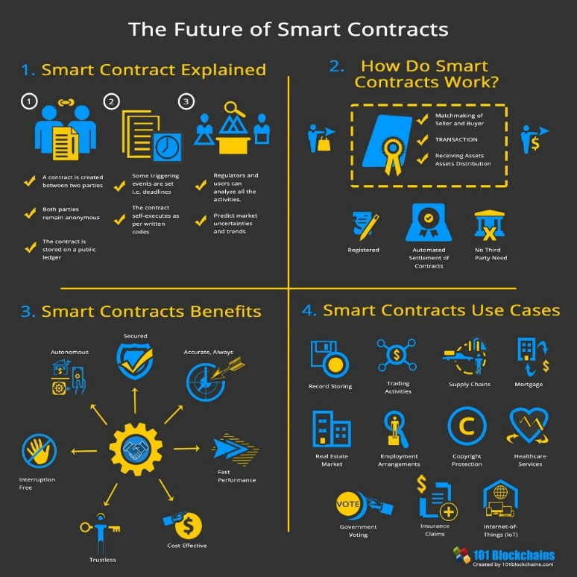

## **Stablecoins - Digital Dollar: How real-world assets are stored on the blockchain**

To understand how finance on the blockchain works, we must first delve into how "value," i.e., USD, is stored on this system. We all have heard of how many digital assets like bitcoin are incredibly volatile and backed by little-to-no inherent value. Outside of the cryptocurrency enthusiasts, a small handful of well-established and regulated firms have taken it upon themselves to bring stability towards the digital asset market. The products they have brought forth are called stablecoins. A stablecoin, at least for the ones applicable to real estate, can be backed by fiat currencies or by commodities.

For example, Paxos, a New York State-chartered trust company regulated by the New York State Department of Financial Services, has created two monumental products, Paxos Standard and Pax Gold (Paxos 2021). Pax Gold was designed to reduce the costs associated with owning and storing gold. Paxos bought a fixed supply of gold and sold the corresponding equity on digital exchanges. Paxos created only the number of shares as there were ounces in storage, and the price was pegged at 1 PAXG = 1 oz of gold. Whatever the market price for gold is at any given time will be the price listed on the digital asset exchanges. Unlike greenbacks today, holders of digital assets can redeem their shares for physical gold through Paxos at any given time. Paxos, practically an agent of the State of New York, has reduced the number of physical transactions of gold and has created a more secure and efficient storage process for the commodity.

Gold is more straightforward, and single commodity exchange-traded funds have existed for a long time. Never had there ever been a demand for digital money. Yes, money is mostly digital now, but just like Pax Gold, digital money in banks was created to be withdrawn. Paxos took advantage of its money transmitter license and earlier successes to bring digital dollars to the blockchain. The new service, called Paxos Standard, was a new, dollar-backed, digital currency. This same service allowed for the digital ownership of fiat-backed digital assets to be redeemed at Paxos immediately, just like a bank. Although it has many similarities with a bank, the one that sticks out the most is its lack of a fractional reserve model. For every dollar issued in value on the blockchain, there is a correlating dollar in the bank account held by Paxos. This means that at any given time, given a bank run, Paxos would be able to service its liquidity with no problem.

## **AMM- Automated Market Maker: Liquidity out of Thin Air**

While in traditional markets only big players can take advantage of arbitrage and market-making opportunities, Defi allows for the ordinary people to collectively pool capital and algorithmically become a unified and profitable market maker (Egorov 2019)

Born out of the ICO (Initial Coin Offering) era, which lead to Bitcoin's crash in 2018, authors of the Uniswap Whitepaper (Adams 2020) created the frameworks to allow for algorithmic, decentralized exchanges. Instead of utilizing order books as traditional exchanges do, Uniswap allowed third parties to provide and remove liquidity to markets without government regulation or regulations. Prices are determined by a constant product formula, relying on liquidity providers and arbitragers to keep the market in equilibrium.

In a typical order book market, there is what we call a bid and ask. There inherently must be a distance between these two numbers; otherwise, both orders would find each other and be filled. When a new player comes into the market, they may place a limit order at any given price or have their order fill instantly with a market order. For someone who wants to make money off the market, they must position themselves on both the order book's buying and selling side. This way, no matter what kind of order, buy or sell, limit or market, the "market maker" will profit from the difference between their positions since they buy for less than they sell.

While this sounds technically sound, this market-making method has a few problems, one being its inequity.  It required a substantial amount of capital, computer and programming resources, and close connections to the exchange computer (CNBC 2019). Clearly not something an individual with $20 in the bank account can make money on.

Years later, blockchain developers created a system for the everyday man, one that does not require vast swaths of capital or immense technological capabilities. While providing capital markets to everyone, this system does not use order books (Adams 2020). Those who want to make money off trading will provide liquidity to a pool. This means that many individuals put assets together into one non-custodial fund that others make trades. The money is made by changing around a 0.3% fee, typically the spread in any liquid market.

On the trading side, the swap price is set up with a price oracle, a decentralized technological function that aggregates several exchange prices. From here, one who wants to create an order or a swap will "call" the current market price and trade with a liquidity pool. The swapper pays a small fee to make the trade, and they go on their way.

RealT (featured below) uses Uniswap as a core part of its secondary market, allowing for liquid, trustless, and pseudo-anonymous secondary market transactions. We shall see later that the trading pair one chooses can affect liquidity. If it's a volatile asset, it would be better priced and arbitraged, and we will see that RealT has an opportunity to use floated funds to buy and crypto sell crypto for a profit, should they choose.

## **Capital Markets**

Because real estate investment is typically made with external financing, either by a bank or by private individuals, creating leans and leveraging equity for more capital. Similarly, within decentralized finance, leverage is even more crucial and has focused on much technological development; this is the financing part of DeFi.

Since margin lending has been outside traditional banking for decades at this point, the concept may not be fresh in everyone's mind. Let us say that you own one share of Apple stock. As a huge fan and a believer in its long-term performance, you do not wish to sell this asset anytime soon. So, your stockbroker introduces you to a man who does not think that Apple will perform well in the next few days. The man says to you, "I will pay you 5% APY to 'borrow' your security." This man wants to short sell Apple, meaning he will sell the stock now and repurchase it later for cheaper. At the end of the period, he will return the store to you with 5% yearly interest. You and the broker are protected by a margin, or collateral, a more considerable amount of liquid value held in the borrower's portfolio. If Apple's share price goes up, the borrower will have to add more collateral or be forced to repurchase the stock at a loss and forfeit his or her collateral. This is because the borrowed value has exceeded the allotted amount, and for the protocol to have its NAV positive, bad borrowers must be rooted out.

The blockchain's margin lending system was created without the need for a trusted third party (like a lawyer or clearinghouse). A protocol called "Compound Finance" is an excellent example of this decentralized financial ecosystem (Leshner 2020). Like margin lending, there are two parties at play, one going long and the other going short. However, there is no broker, as this is done with pre-audited code called smart contracts. One party will post collateral, typically Ether, a popular cryptocurrency, and ask for a loan worth roughly 50% of the collateral value. The APY naturally fluctuates with supply and demand. Still, it is usually around 10%, a way more robust return on holding short-term funds than the current anemic rate (less than 1% APY). Another party will provide stablecoins to the borrower and collect the interest payment.

The collateral is managed by a system of computers known as keepers. They make sure that the collateral value is safe and will contact the borrower if there is a liquidation risk. If there is ever loan collateral that is reaching dangerous values, any individual may come in and purchase the debt. The purchaser is required to post the margin, and in return, they may redeem the underlying value.

So why would someone ever do this? Well, unlike margin lending, there is no one going short. Because the other asset is a stablecoin, considered a risk-neutral position, only one person is going long. If someone believes in Ether, they may almost double their work by using this protocol. Now, if the price goes up, they will easily be able to pay from their profits. If it goes down, then the lender will benefit. Either way, for the lender, this is a win-win.

As of July 30, 2020, there were $2.7 billion locked into these protocols, up over 100% the last few months. (Late February 2021, $35.1 billion.) There have been many recent developments in this technology and a handful of capital firms and institutional investors heavily investing (e.g., Tesla). For someone who is distrustful of banks and embracing the future, it is the place to be financial.

Exhibit 4 is a screenshot of AAVE, an extensive lending protocol with a little less than $10 billion in its system. As you can see, there are seven digital dollar markets—other protocols such as Compound Finance and MakerDao also employ "self-driving bank" technology.

Source: Aave.com

# **RealT CASE STUDY**

Real T is one of several known companies (i.e., Roofstack and Realblocks) marketing fractional tokenized ownership of residential properties on the www. RealT transactions are managed/maintained on the Ethereum blockchain. Although you can buy a token with crypto, USD is the common currency. Thus, this case study focuses on the blockchain rather than the crypto side of innovation.

## **Demand-side: investors**

US investors must be high-income/net worth accredited investors on the demand side as per SEC rules. Once vetted and admitted, investors can purchase property shares as they become available in the primary (like an ICO) market. There is also a secondary market for shares that can be bought and sold after origination. Properties offered under SEC Regulation C to US accredited investors and to and foreign investors under Regulation S in separate tranches. Foreign investors need not hold qualified investor status. We consider Both Reg C and Reg S properties interchangeable for this case study. Investors buy "units" (tokens) of about $50 each, which is the minimum stake. If a specific property is worth, say, $65,000, about 1,300 units would be available. Each investment unit offers a stated return, say 11%, payable monthly. Investors can buy as many shares as they like[1]. All rent distributions, ownership, property maintenance fund management, and other transaction-related activity are transparently available for viewing on the blockchain, and rent payments are direct-deposited via smart contracts[2]. The website employed by RealT uses public blockchain data to create an interactive dashboard for RealT investors and those curious potential investors. It provides maps, trading data, and rental disbursements (<https://dashboard.realt.ch/map>). A few examples are provided in Appendix A. RealT sees its leading service to token buyers, keeping the quality of cash flows reliably.

**Supply-side: RealT and originators/developers**

On the supply side, RealT is a two-year-old startup with about 70 properties in its nascent portfolio. Its primary function is to provide a bridge between independent originator/developers who list their properties on RealT's blockchain platform, thus enabling investors to access them and buy tokenized ownership equity units. The specific property is a single-family house in good condition in an inner-city neighborhood (mostly in Detroit, but a few in Cleveland, Akron, and Rochester, NY). Because they can be bought cheaply (supply exceeds demand in central city markets), many are in excellent physical condition and modest repairs and upgrades. They can be brought into the RealT portfolio as independent LLCs as fully rented and generating returns above 10%. The property transactions appear twice in the public record a few weeks or months apart: once as the originator/developer acquires the house off the market at a local price, and a second time when it's put into the RealT portfolio at its higher, securitized price. While these homes can offer substantial positive cash flow, long-term appreciation is likely negligible in these markets. Once in the RealT portfolio, tenants pay rent to the LLC, a property management entity (potentially likely the developer but more likely a separate form specializing in property management) that manages rent collection and deals with maintenance issues. These net funds flow onto the RealT blockchain and are distributed to unitholders as per the smart contract. Exhibit 5 below shows the ownership structure and cash flow stream. The process of entering into a legally binding RealT financial agreement includes the originating LLC, tenants, management company, and RealT at the property and system levels, and of course, the token buyers.

Exhibit 5: RealT System Ownership Flowchart

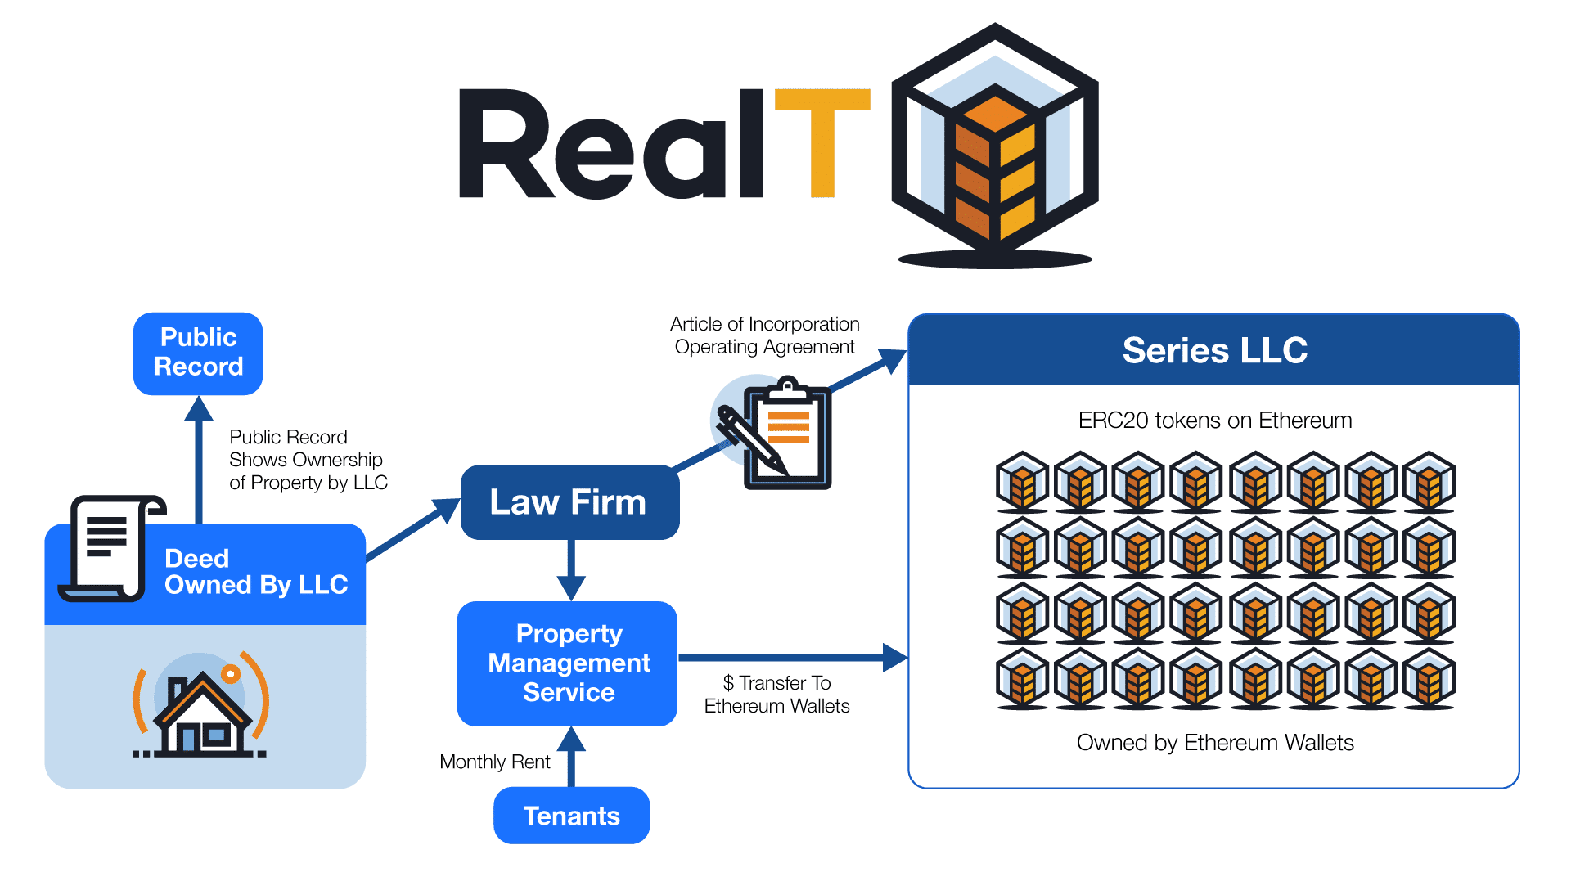

Source RealT 2021

## **The RealT portfolio**

We started tracking Real T in late November 2020. At that time, there were 19 properties in the inventory. RealT grew to 35 properties by January 20, 2021. By February 10, 2011, there were 43 properties in there, with several added every week or two. Our recent interview with the RealT founders revealed that they had about 70 properties as of March 5, 2021. Most of the properties are in Detroit, Michigan. Exhibit 6 shows the current RealT portfolio profile, broken down into the Detroit single-family/doubles and other (a few apartment buildings and detached houses outside Detroit).

Exbibit 6: February 2021 RealT Listed Property Portfolio (top panel - data, bottom panel - property maps)



The RealT portfolio is pretty typical of an inner-city market: properties often have three bedrooms, 1.5 baths, about 1,300 square feet, are over 80 years old, and generate gross monthly rents of $870, about $0.75/SF/month. The entire tokenized price is approximately $66,000, and there are about 1,300 tokens priced at $53/token offered to investors. These tokens provide returns above 10%. Interestingly enough, over half of the tenants in these rentals are Section 8, which could have significant upside implications for stable cash flow, low turnover, higher property maintenance costs, and cash flow stability. The properties outside Detroit are small apartment buildings (average of 10 units per property), with an average unit size of about 800 square feet (SF), with similar rent and tenant profiles. Those deals had a tokenized value of about $430,000 and offered 5,600 tokens (average cost $85) per property to investors, at slightly lower but still healthy returns.

## **The buy and getting the property into the Real T inventory**

There are two parts to this analysis. First is the buy and listing of the property, followed by its ongoing cash flows offered to investors. On the buy-side (individual property origination), the typical single-family property had a RealT syndication value of about $65,000. However, cross-checking the property on Zillow showed that the Zestimate was nearly half that or $35,000-$40,000. The same property would likely have the same rent on Zillow and in the RealT offering statement of $850 per month. Thus, it appears there is substantial upside in listing the property on RealT (basically flipping it), and the following assumptions corroborate this. Even after allowing for $10,000 for repairs and upgrades, marketing and financing costs, seeding property maintenance funds, a one-time Real T syndication/tokenization fee of 5%, the potential lightly leveraged profit margin is about 18%, an excellent return. This is detailed later on the top left side of Exhibit 8. RealT works closely with owners/developers, who generally do not act as property managers, which is considered a specialized field. Section 8 tenants are a niche market, with stable cash flows and high property maintenance requirements from constant government testing. These Section 8 properties require large reserves, which are sequestered on a property-by-property basis. RealT can manage the float on these funds, often at desirable interest rates (currently short-term rates in the 5-10% range), in crypto markets. At this point, RealT is selective on which properties get into their portfolio, and they must all be leased, in excellent physical condition, and have maintenance reserves set aside, especially if their tenants are Section 8. They also try to have more than one property manager in each city as a back-up.

Once the property is listed, rents from a fully-occupied property support a projected rate of return, after property taxes, maintenance, marketing, a vacancy allowance, and a Real T service fee of 2%, and a management fee of 8%, that likely accrues to an outside property management company[3]. The available net cash flow of $7,300/year is distributed in proportion to ownership in the property. See Exhibit 7.

Exhibit 7: Single Unit Cash flow Example offered to Investors



Source: RealT

## **Scalability of the RealT model**

Having set the basic assumptions, we now examine how scalable this model is for both the originator/developer and RealT, the blockchain company. For the originator/developer, we assume they operate in a metro area they know well. We assume they can select appropriate houses or apartment buildings, buy properties at or below-market prices, rehab units, obtain financing for repairs if needed, market the units, and fill them. Each unit should take three months or less to acquire, do the physical rehab work, rent up and place on the blockchain. We assume the originator/developer desires to grow the properties on RealT to achieve cash flow. The property managers also seek some economies of scale[4].

Based on these building blocks, Exhibit 8 shows the scalability of the RealT model. We examine returns to the originator/developer on the left side, and the top left quadrant restates material presented above for a single unit and expands it for 10, 25, and 100 units. We address both cash flows for the original placement/development and ongoing cash flows from property management. Note that by the time the originator/developer places the property on the blockchain, they have cashed out. Unless they own tokens, they have no money left riding on the property, just the opportunity to have some entity (probably another) manage the unit for a fee. From the developer's perspective, most of the money is in listing the properties (shown above the black bottom line) rather than ongoing management (at the bottom of the left side). Each property has a nice profit (estimated at 18% using these assumptions) for "flipping" the stuff onto the blockchain. The property manager would need 100 units to net $50,000 a year on those fees. The items in red show RealT's take, both on origination and for ongoing servicing.

On the right side of Exhibit 8, we show RealT's earnings at a larger scale since they are presumably doing this in numerous markets. Likewise, the bulk of their funds comes from the one-time-per-property listing/securitizing fee. At 1,000 units under management, the fees they'd make (over $3 million) look like it could support a business nicely. Other income comes from the ongoing service fees and the float on numerous sequestered property maintenance funds, which can currently generate 5-10% returns per annum on short-term loans on the crypto markets.

Finally, at the bottom of Exhibit 8, we combine these growth scenarios over a five-year ramp-up period for both the individual originator/developer. For the city-originator, we assume a steady increase to adding up to 30 new units a year onto the blockchain, yielding about 100 total units under management by year 5. The revenues do look sustainable and could likely support a few employees, although the mix of revenues from origination rather than management stays relatively high, at almost 90%. Further, net gains from property management are only about $60,000 a year. To make "real" money (not RealT), the entrepreneur would likely have to grow faster than we show here. On the other hand, if originator/developers tokenize apartment buildings rather than houses, or if the homes are more expensive and can still generate adequate returns such that investors would buy the tokens, the revenues would increase.

From the perspective of RealT, we assume they can add five cities (each having an originator/developer performing similar to that shown on the left side panel) a year, up to a total of 30 urban markets within five years. That gives them 900 (single family-sized) properties on the blockchain from all sources by year 5. Using these assumptions, they break $1 million by year four and have an excellent upward trajectory after that. If their originator/developers tokenize more expensive property (e.g., apartment buildings) and generate adequate returns such that investors would buy the tokens, the revenues would undoubtedly be higher.

Exhibit 8: Scalability of the RealT Model



## **SECONDARY AND INDIRECT BENEFITS OF THE RealT PROGRAM**

Detroit is not alone. Cities like Cleveland, Buffalo, St. Louis have stable rents and declining asset values due to negative population growth. These markets can offer a high cash-on-cash return to real estate investment and quickly hit the 10% threshold attractive to online token investors. There are likely dozens of markets in the US where RealT could be replicated, and in larger markets, there could be room for more than one local originator/developer.

Since the typical Zillow market price of an asset in the RealT portfolio appears to be about 50-75% of its securitized price (but rents are about the same), there are several implications. First, there is profit potential for the investor to acquire the property, get it fixed up, leased up, and flip it into the RealT online portfolio. The value-add here seems to be both the physical/rent-up and that securitizing it allows a way to find token investors that increase the asset price and still produce 10%+ returns. Nevertheless, property maintenance funds and other items dilute the return at the origination phase.

But bringing residential properties into the RealT portfolio also potentially increases property values in the inner city. These sales are legal and registered with the local authorities, and appraisers can use them as comps in nearby evaluating properties. This assumes substantial appreciation/value-add between the first (original acquisition off the market) and second (finished unit, rented and placed into a property-specific RealT LLC) transaction. Thus, this could swing the house price pendulum back toward higher values, larger mortgages, and higher net worth for owners of inner-city residential property. This is a good thing[5]. Increasing inner-city property values has been a thorny, even vexing societal issue and directly affects wealth creation among African-Americans and other minorities (Perry, 2020, Chapter 2). Buying up real estate with interested capital partners could help stabilize and redevelop neighborhoods and fuel property value appreciation. Perhaps investment in RealT could also satisfy a Bank's CRA (Community Reinvestment Act) requirements.

Another intriguing observation is the prevalence of Section 8 tenants in the RealT portfolio. This type of tenant tends to be very stable, so rental turnover is minimized. The required property quality adds a sense of oversight and assurance that the property conditions are maintained. In a sense, RealT could be looked at as a type of Section 8 secured portfolio backed indirectly by the US government. However, there are added expenses because these properties require a more extensive property maintenance budget and attention to more frequent government inspections.

# **RealT capitalizes on the structure of decentralized finance.**

Benefits of transparent blockchain investments: All transaction data are public. Transparency in pricing assets, including buying, selling, rent payments, amounts and participants, primary market, secondary market with live secondary pricing data, and transparent visualization of dividends and liquidity in real-time. It also offers automated market makers the potential to receive profits of the bid-ask spread, where both buy-side and sell-side orders and large amounts of liquidity, including bid-ask spread, are shown. Finally, dividends paid without ex-dividend date, where those who own at payment time receive payment, without any unwieldy prices swing to calculate expected dividends. See the last chart in Appendix A

# **CONCLUSIONS AND FUTURE RESEARCH**

Blockchain technology is a platform for transactions and investment. It includes cryptocurrencies, of which there are dozens of investment vehicles, of which Bitcoin and Ethereum are the best known. Crypto is an emerging asset class and offers some portfolio diversification benefits, as well as attractive rates of return, subject to "translation" or conversion back into underlying currencies like the US dollar. Blockchain allows ease of access and transparency and provides a cloak of anonymity, which may be incompatible with owning real estate, which generally has ownership and transactions as public records. Everything is hidden in plain view.

This paper has provided a primer on the intersection of blockchain, cryptocurrencies, and real property. It reviews the various ways that these emerging technologies and instruments are used in real estate investment today. We did a case study of a blockchain-oriented investment platform called RealT. Their business model and customer-servicing interface appear to be sustainable for token buying investors, originator/developer partners that list and manage the properties, and the parent company that provides a marketplace where properties are tokenized on the blockchain with smart contracts. Real estate is acquired and held with "crowdsourced" equity and no debt. We look ahead to ponder future directions over the next five years. The best qualities of cryptocurrency and real estate overlap and may form a robust and sustainable investment environment.

Some loose ends: We are not sure of the exit strategy for owning these houses. Perhaps you just sell your tokens, or one owner can accumulate tokens, likely at a reduced price, maybe after a non-payment event (say vacancy), above and beyond the 9.9% ownership cap. Still, it seems like the house itself is forgotten, and it's unclear if the relatively modest 5-8% management fee is enough to keep someone focused on repairs and lease-up when owners are scattered to the four winds and anonymous.

One answer may be to get neighborhood community development corporations (CDCs) groups involved. They are in it for the long haul, and building up their turf with RealT could be an attractive way to build their balance sheet, get a property management fee, and build up and maintain their territory. If token prices drop, or even if they do not, CDCs could acquire them and hold ownership or even pass it off to tenants on the secondary market.

Also, the rental property generates an annual depreciation allowance of 3.63% of the property's non-land part. This tax advantage is processed for US investors, but it is unclear if these benefits flow through to token holders in a 1099 format. For Reg S foreign investors, depreciation is left on the table, and in the future, it could be monetized by RealT at the corporate or LLC level. We are not sure how this is allocated. Maybe after income tax time, I'll find out since I own a few tokens in a Detroit RealT house.

While RealT founders were lukewarm on the pure profit between the first and second transactions of the originator, a careful buyer could likely beat the 18% returns in a soft housing market. Thus, the potential for upside arbitrage in house prices could be more significant than is modeled here.

Future research includes a secondary market for tokens, more volume on RealT, other similar firms, creating a token index, and watching to see within a few years if local house prices creep up. Finally, more thought needs to be put into the apparent fact that RealT is essentially Section 8 backed security and related implications. The future is bright for this new type of real estate finance and competition; SEC changes (for example, limiting token purchase only to accredited investors) and greater market depth seeking higher returns could move it upward by order of magnitude.

# **REFERENCES**

Adams, Hayden. Uniswap. URL*:* [*https://uniswap.org/docs/*](https://uniswap.org/docs/)

<https://dashboard.realt.ch/map> This website uses public blockchain data to create an interactive dashboard for RealT investors and those curious. Provides mapping and trading data as well as information on rental disbursements.

<https://defipulse.com/> Data aggregation website putting together all financial holdings of decentralized finance platforms.

<https://www.coindesk.com/bloomberg-terminal-lists-ethereum-based-debt-instrument>

<https://www.centre.io/usdc>

<https://www.paxos.com/paxgold/>

https://cointelegraph.com/news/comparing-money-laundering-with-cryptocurrencies-and-fiat

<https://www.jpmorgan.com/commercial-banking/solutions/commercial-real-estate/community-development-banking/community-development-banking-faq>

<https://www.jpmorgan.com/commercial-banking/solutions/commercial-real-estate/community-development-banking/new-markets-tax-credit>

<https://www.policymap.com/2015/07/mapping-cra-eligibility/>

<https://dashboard.realt.ch/map>

<https://www.policymap.com/2015/07/mapping-cra-eligibility/>

<https://www.cnbc.com/2019/08/01/goldman-spending-100-million-to-shave-milliseconds-off-stock-trades.html>

https://www.curve.fi/stableswap-paper.pdf

<https://uniswap.org/whitepaper.pdf>

<https://aave.com/>

Jacobson, Remy, and Jean-Marc. RealT founders, zoom interview, March 5, 2021

Leshner, Robert and Geoffrey Hayes. Compound: The Money Market Protocol. Feb. 2019. URL: [https://compound.finance/documents/Compound. Whitepaper.pdf](https://compound.finance/documents/Compound.%20Whitepaper.pdf).

Perry, Andre. 2020. Know Your Price. Washington DC: Brookings Institution Press

RealT. Legally Compliant Ownership of Tokenized Real Estate. White paper. <https://realt.co/education/> last accessed February 23, 2021.

Schär, Fabian & Schuler, Katrin & Wagner, Tobias. (2020). *Blockchain Vending Machine: A Smart Contract-Based Peer-to-Peer Marketplace for Physical Goods.*

Vitalik Buterin et al. 2013. Ethereum white paper. GitHub repository (2013).

# **APPENDIX A: TYPES OF DOCUMENTS AVAILABLE TO RealT TOKEN HOLDERS ON THE BLOCKCHAIN IN REAL TIME**

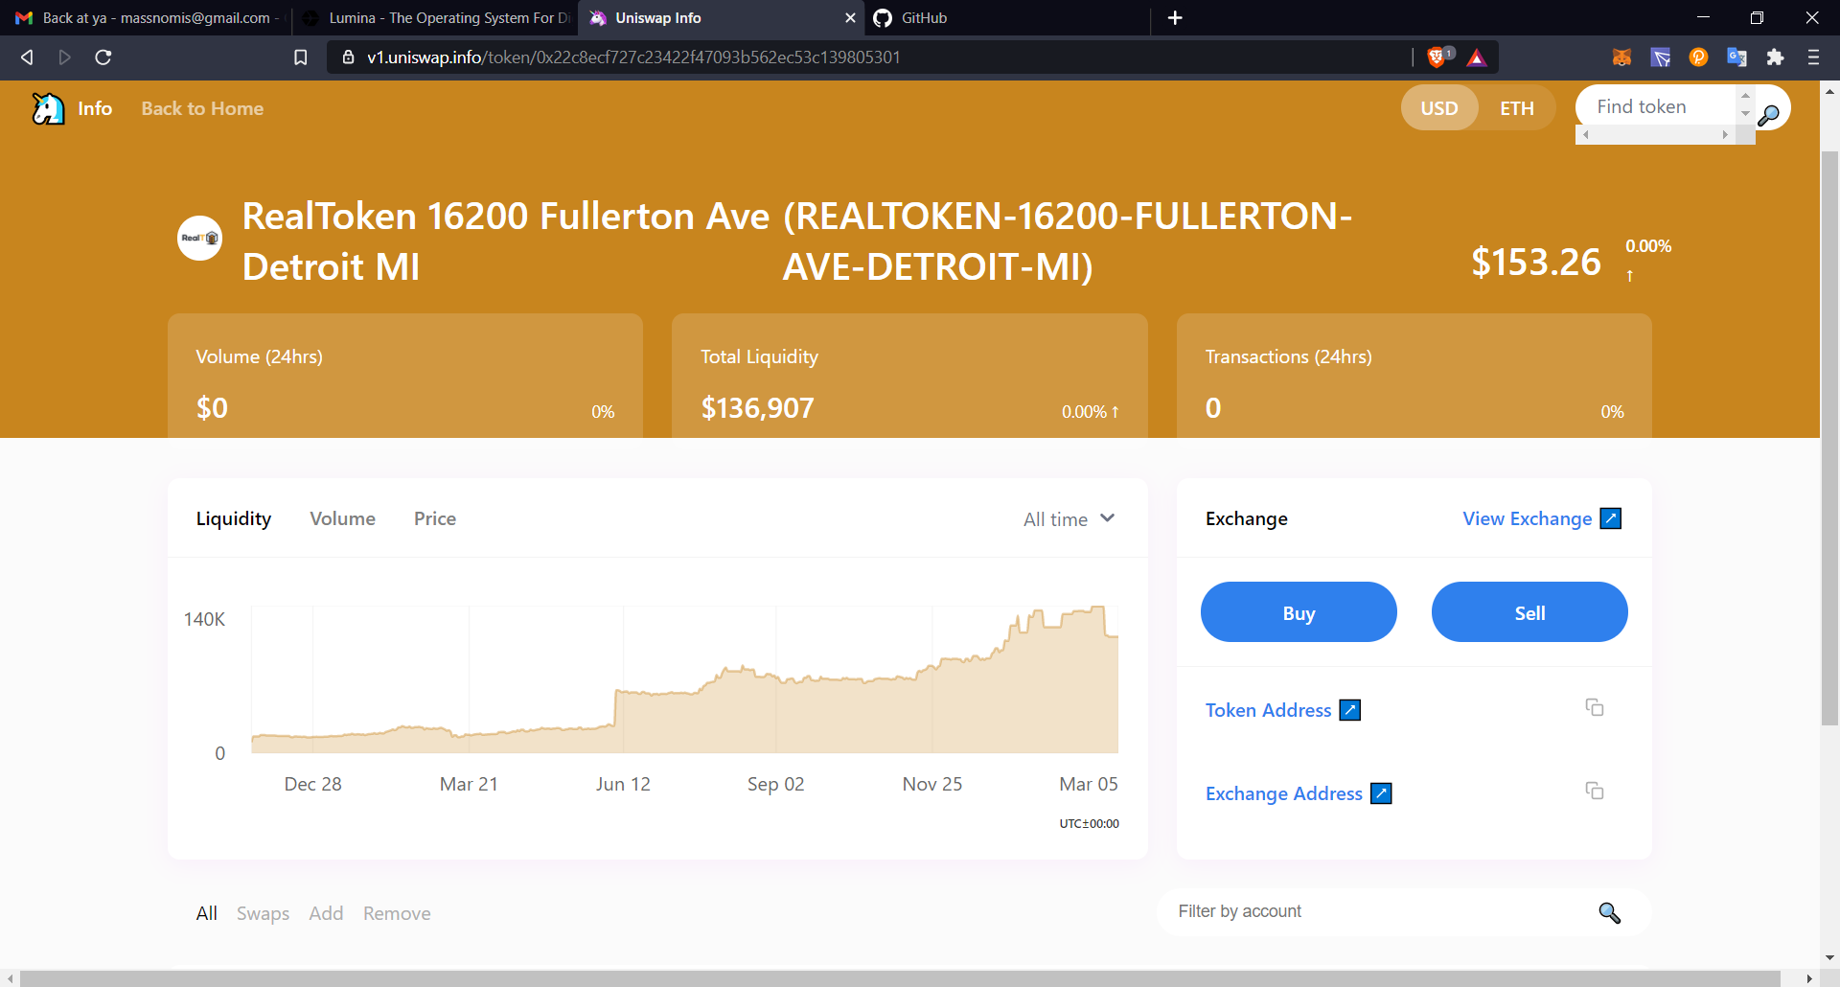Eth price changes bring volume and liquidity

Asset transparency

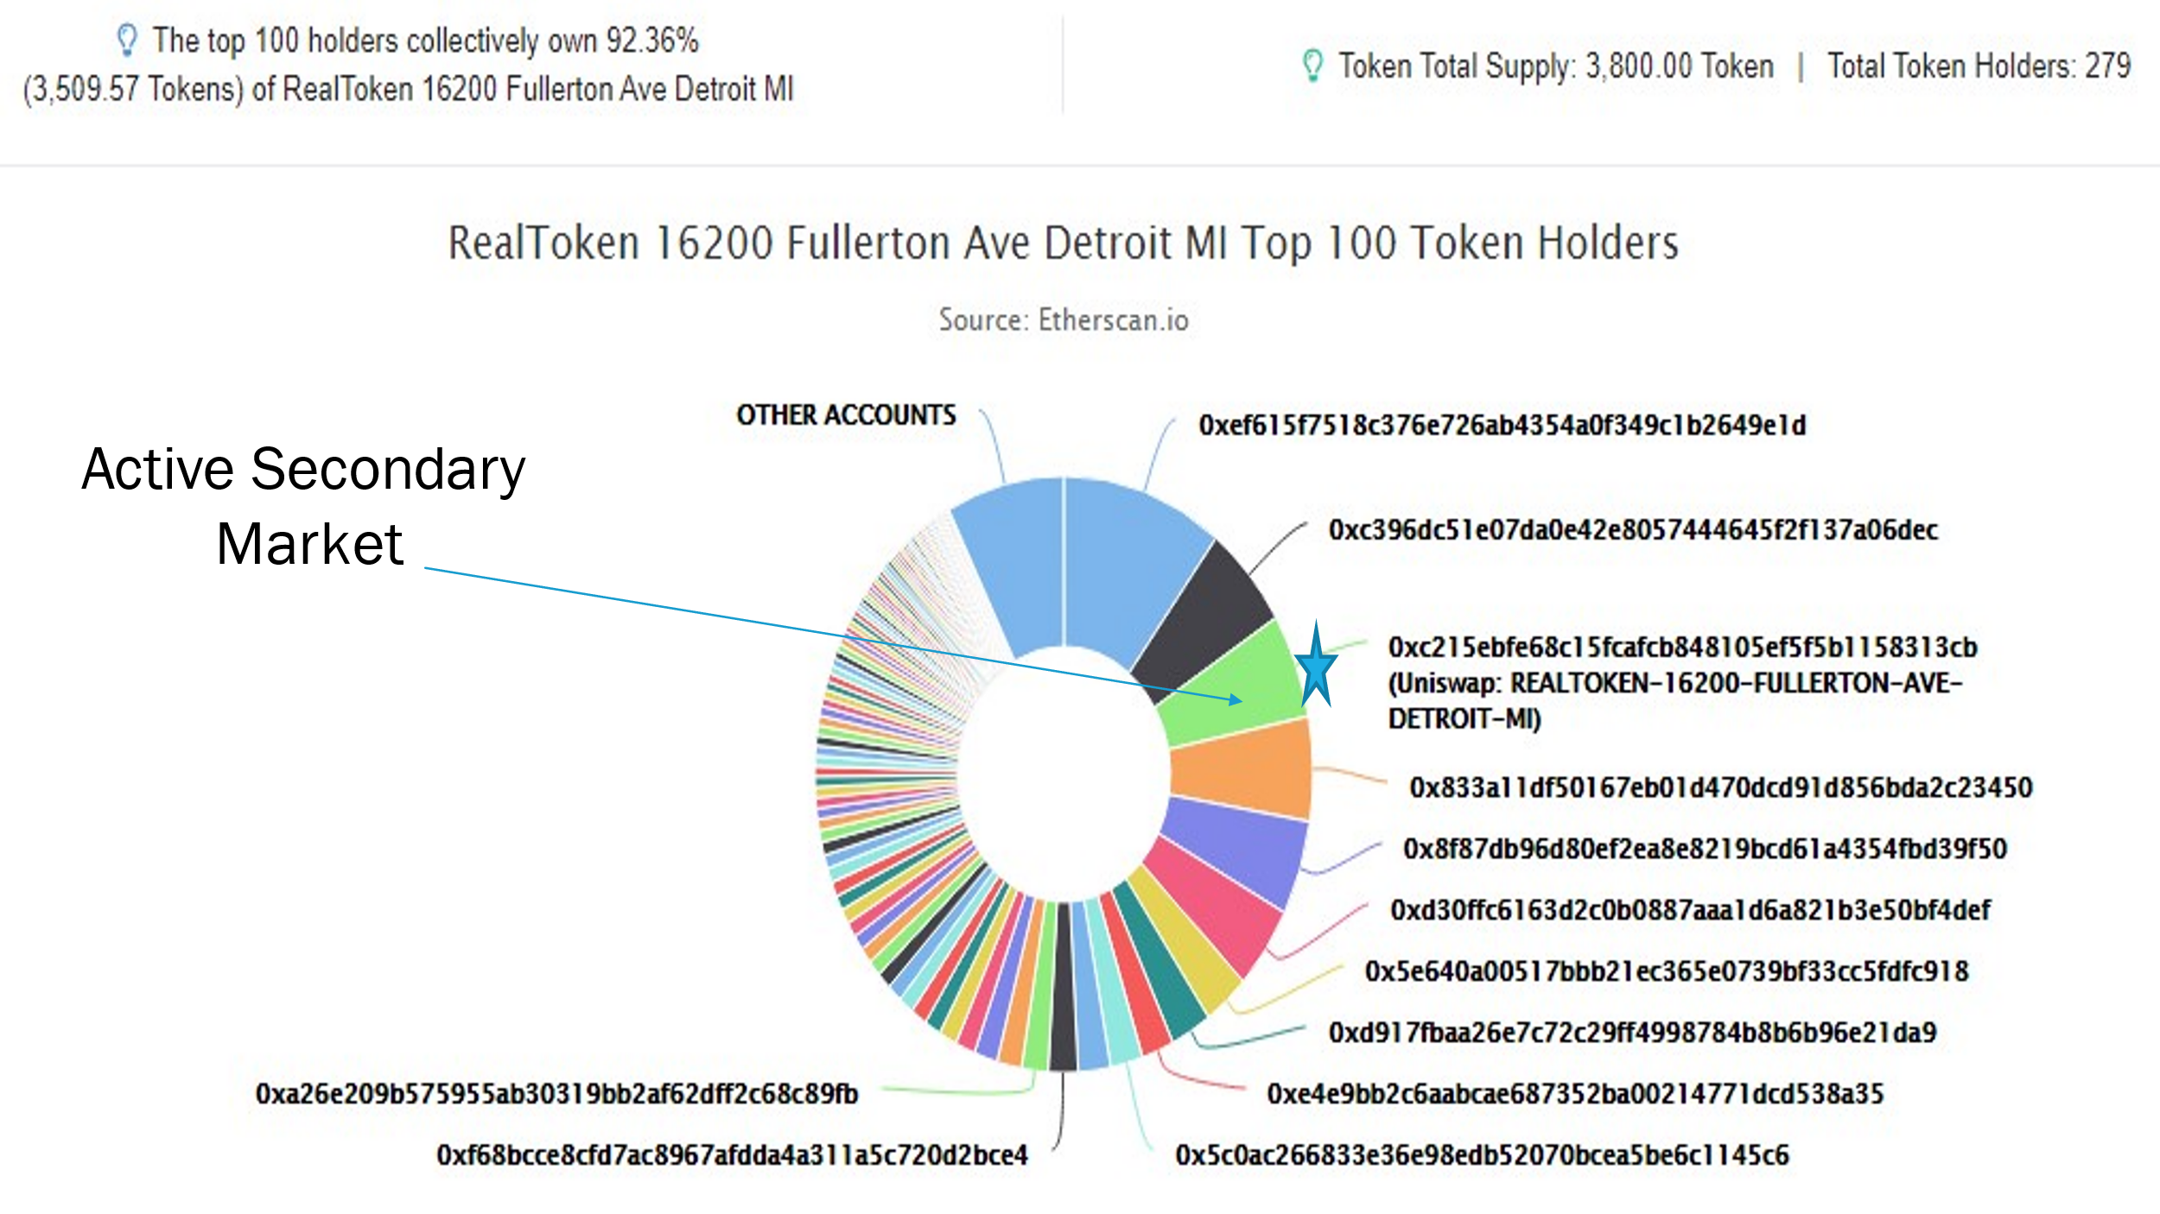

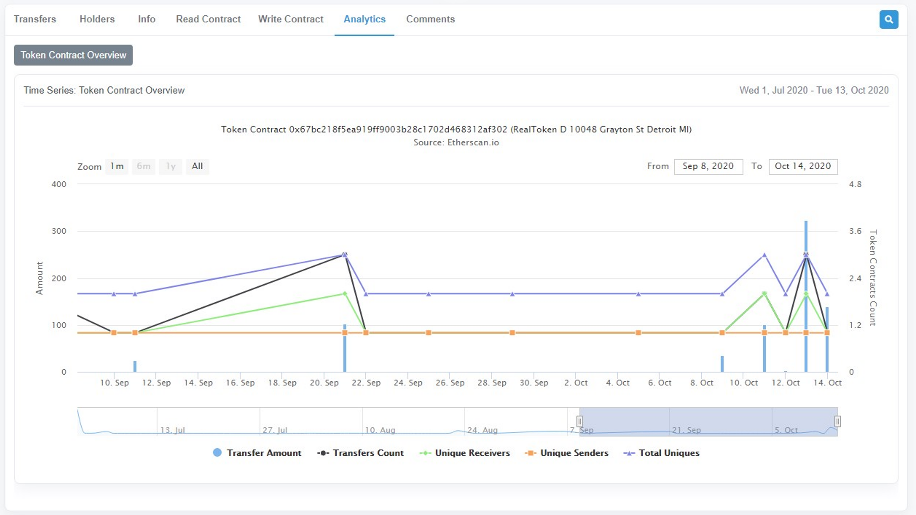

RealToken analytics; sends, trades, buys, contract interactions

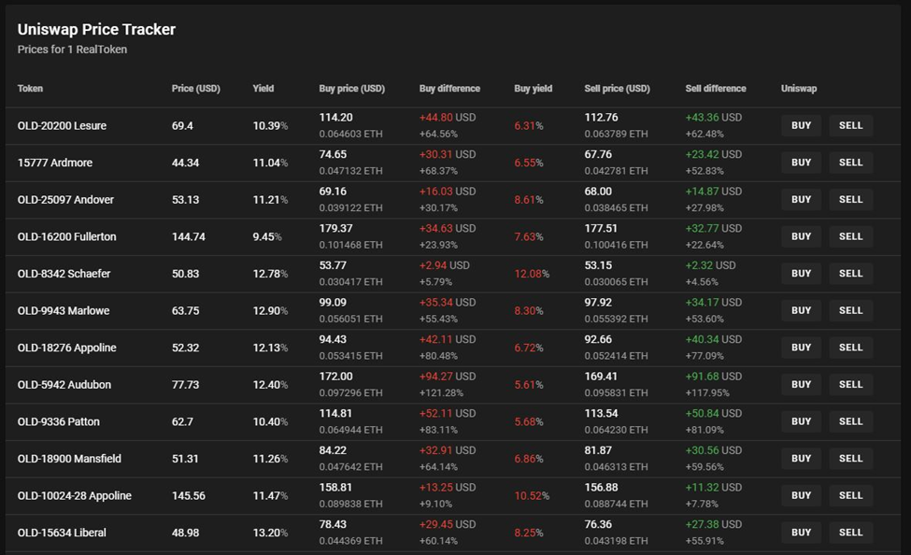

Trading dashboard, with yields included, price as bonds

1. At least up to 9.9% of the total number of tokens available. Further, at least at this time, RealT offers some “guaranteed buyback” provisions, though it is unclear how sustainable these are in the long run.
2. The types of reports available to investors on ownership, distribution of cash flows and other items are remarkable and numerous. They are graph based, and show all the property’s expenditures, but everything is anonymous, as owner units are identified by numbers not by name. They are updated in real time and are remarkably transparent.
3. The RealT contract calls for a slightly lower cut, but also allows for additional management fee for distributing maintenance funds.
4. Zoom interview with Remy and Jean-Marc Jacobson, RealT Principals, March 5, 2021.
5. On the downside, if property values go up, so will property taxes, so some people will complain about that.